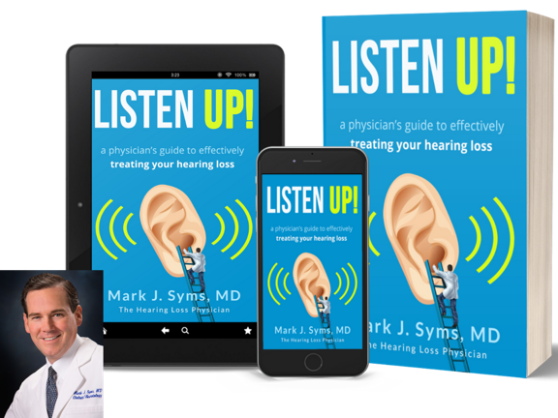
FOR IMMEDIATE RELEASE
Contact Info:
Maria Syms, Esq.
contentmanager@azhear.com
602-430-0472

DR. MARK J. SYMS “THE HEARING LOSS PHYSICIAN”
RELEASES HIS NEW GROUNDBREAKING BOOK:
LISTEN UP! A PHYSICIAN’S GUIDE TO
EFFECTIVELY TREATING YOUR HEARING LOSS

PHOENIX, AZ – FEBRUARY 22, 2021 – Americans spend a fortune on hearing aids every year – yet 25 percent of hearing aid users abandon them within 6 months because they are uncomfortable or don’t help.

“What many people don’t realize is that to be effective, hearing aid settings need to be finetuned/adjusted over time, typically for the first several months of use and periodically over the years,” says Mark J. Syms, MD, a physician specializing in hearing disorders and the author of the new book, Listen Up! A Physician’s Guide to Effectively Treating Your Hearing Loss.

It is estimated 28.8 million Americans could benefit from using hearing aids. That number is rapidly climbing with the COVID pandemic increasing demand for hearing aids as masks make it impossible to compensate by lip reading. A recent Hearing Loss Association of America survey found 95% of participants reported face masks have “created communication barriers since the pandemic began.”

With recent evidence of COVID related hearing loss, that number is only getting higher. According to the International Journal of Audiology, “More than 1 in 10 COVID-19 adults report a change in their hearing status, when questioned eight weeks after discharge from the hospital.”

“Hearing aid technology has made incredible leaps in the past several years, and with so many people in their 50s and 60s getting hearing aids for the first time it’s essential that they know how to get optimal benefit from these devices,” Syms says. “So many people come to me saying their hearing aids don’t work and my answer is always the same – it’s not the hearing aid. Costco may deliver you an affordable hearing aid but that doesn’t necessarily mean it is giving you the quality, follow-up service that an experienced specialist provides for that hearing aid to be effective. I can’t tell you the number of times I see patients with unused Costco hearing aids.”

“I wrote Listen Up! to give hope and answers to those struggling with hearing loss or with hearing aids that don’t work,” says Syms.

In Listen Up!, Syms explains, in simple terms:

- What questions to ask your provider regarding your hearing loss;
- Why it is important to treat your hearing loss sooner rather than later;
- How effectively treating your hearing loss will allow you to continue to live independently and enjoy social relationships with family and friends;
- How you can protect yourself from Alzheimer’s and dementia associated even with minor hearing loss; and
- How you can optimize your hearing aid capabilities.

As a hearing loss physician who has treated tens of thousands of patients over the course of thirty years, Syms knows firsthand that better hearing means a better life.

Syms is an experienced public speaker who has given lectures on hearing loss all over the world and has authored articles in numerous medical publications. Syms is available to discuss tips for maximizing hearing aids to improve your life.

-end-

